# ABSTRACT OF THE DISSERTATION

Title

by John Braley

Dissertation Director:

Franklin L Moon

Begin text here.

# Table of Contents

ABSTRACT OF THE DISSERTATION ii

Table of Contents iii

List of Tables v

List of Illustrations vi

Introduction 1

Heading 2 2

Heading 3 2

Part 1: Understanding vehicle-bridge interaction and dynamic amplification 3

Experimental Case Study 3

Description of Test Structure 3

Phase 1 Testing 4

Phase 2 Testing 5

Phase 3 Testing 7

Test Conclusions 11

Simulating VBI 11

Bridge and vehicle decoupled 12

Mechanisms and Influential Attributes 12

Part 2: Estimating Dynamic Amplification 15

Visualizing the Problem 16

In-Situ Measurement 17

Operational Monitoring 17

Load Testing 18

Profile Measurement 19

Finite Element Analysis 19

2D Condensation & State-Space 21

Description 21

Implementation 22

Validation and Performance Assessment 23

IRI & Other Vehicle-Only Models 25

Summary 27

Part 3: Applications in Vehicle-Bridge Interaction 27

Remediation and Smoothness Criteria 27

Vehicle Configurations 29

Traffic 29

Truck Trains 29

Future Work 29

# List of Tables

# List of Illustrations

# Introduction

This document aims to explain and demonstrate the behavior of a bridge under a moving vehicle. Before I embark on that effort I feel obliged to define a few terms that you may notice to abound throughout the following pages.

The first is “vehicle-bridge interaction” (VBI), which refers to the scenario in which one dynamic system (vehicle) traverses a second dynamic system (bridge). The vertical translation of the vehicle is coupled to that of the bridge at the wheel contact locations. Vehicle-bridge interaction therefore refers to the behavior of the combined system.

The second term is “dynamic amplification”, which quantifies the inability of static analyses to predict the maximum response of a dynamic system. It is expressed as a ratio of maximum dynamic response to static response. For a bridge, moving vehicles excite the coupled system resulting in bridge motion which in turn causes member level responses unequal to those that would result from the force of the vehicles’ weight alone (static).

For many civil applications, static analyses have proven adequate for determining the demands of structures. Structures often remain near enough to a motionless state that the structure can be described as a static system, and the resulting error from employing this assumption can be accounted for with a small increase in the factor of safety. However, in other cases, the deformation experienced by a structure associated with its motion is appreciable, as is seen in seismic events.

Live load demands have historically been estimated using static analysis. The dynamic amplification factor that should be used depends on the design specification with jurisdiction. According to AASHTO, a maximum factor of 1.33 is to be used. However, there have been numerous reports of bridges experiencing dynamic amplification well in excess of this number. Extensive structural monitoring was performed on one such nonconformist as detailed herein.

These bridges with excessive dynamic amplification suggest that old assumptions are no longer conservative for every bridge. We are therefore compelled as designers, builders and operators to identify the shortcomings of old assumptions and develop more accurate methods as required.

# State of the Art

## Heading 2

### Heading 3

#### Heading 4

Text: The quick brown fox jumps over the lazy dog. The quick brown fox jumps over the lazy dog. The quick brown fox jumps over the lazy dog. The quick brown fox jumps over the lazy dog. The quick brown fox jumps over the lazy dog.

The quick brown fox jumps over the lazy dog. The quick brown fox jumps over the lazy dog. The quick brown fox jumps over the lazy dog. The quick brown fox jumps over the lazy dog. The quick brown fox jumps over the lazy dog. The quick brown fox jumps over the lazy dog.

More information can be found here: [https://gsnb.rutgers.edu/academics/electronic-thesis-and-dissertation-style-guide#sample](https://gsnb.rutgers.edu/academics/electronic-thesis-and-dissertation-style-guide%23sample).

Image Placeholder

Figure 1: Test Image

# Part 1: Understanding vehicle-bridge interaction and dynamic amplification

This first part details the experimental testing and investigation of a real bridge and documents the knowledge gained from such efforts. Recording a phenomenon is the first step in understanding it.

## Experimental Case Study

The case structure was brought to our attention by local transportation officials. By their report, motorists have repeatedly contacted local police to report what they perceived to be excessive vibration. This prompted a series of field tests in which various structural responses were recorded under typical operational conditions. Testing objectives were driven by the DOT’s directive to identify and characterize the bridge vibration and determine if they may be detrimental to the structure’s performance. The testing activities, results and conclusions are summarized in the following sections.

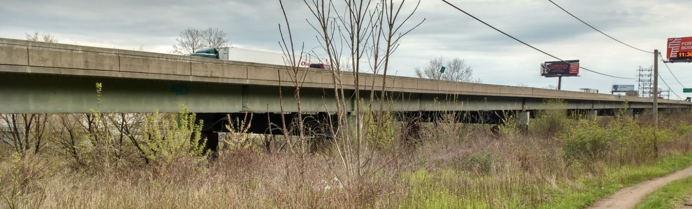

### Description of Test Structure

The structure is an 11-span viaduct that carries 4 lanes of a major interstate highway. The viaduct was first constructed in 1952 but the superstructure was replaced in 1986 while retaining the concrete piers. East bound and west bound lanes are carried by adjacent steel multi-girder spans, which are supported by steel box-girders spanning between two piers. The structure was overall in good condition with no significant cracking or corrosion visible.

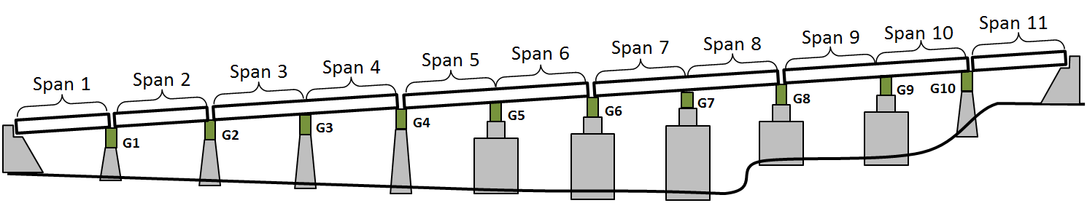

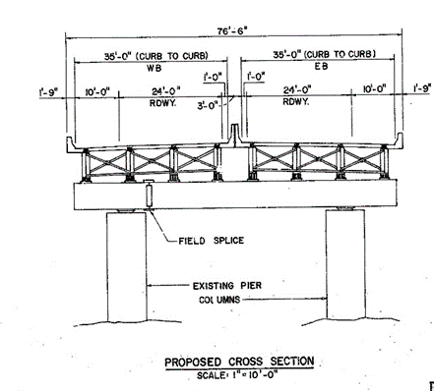

#### Superstructure

The structural type is steel multi-girder. Eight girders run longitudinally, resting on steel box girders that span transversely and are supported by the concrete piers. A reinforced concrete composite deck was cast in place, with a “raked” finish and no overlay. The deck is discontinuous between girders 4 and 5, thereby creating two adjacent structures.

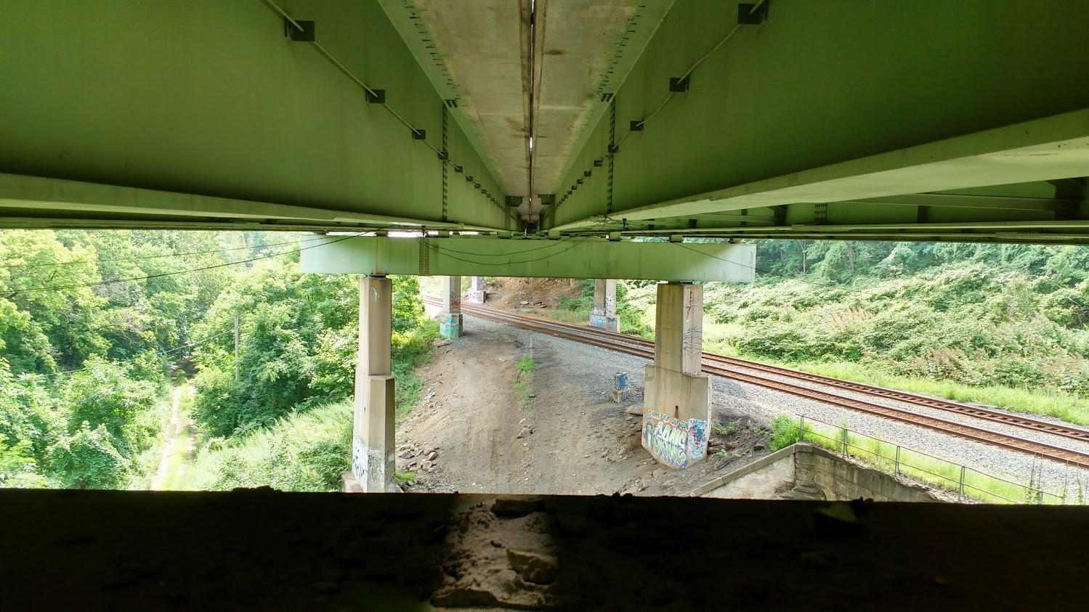

Figure : View of Deck Separation

There is no skew. The bridge has eleven spans. The maximum span length is 140’-0”. The out-to-out width is 76’-6”. Three spans are simply supported (1, 2 & 11), while the remaining eight are two-span continuous. Each span has five interior rows of X-framed diaphragms and chevron diaphragms over the piers. The following figure enumerates the girder layout which will be referenced in the following sections.

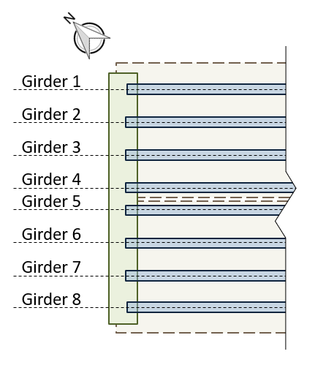

#### Substructure and Bearings

The concrete piers and abutments were constructed in 1952 and are all that remains of the original structure. They are supported by driven piles. Elastomeric bearing pads are installed on top of the piers and support the transverse box girders. Rocker bearings or pedestals are installed between the box girders and longitudinal girders at those locations which are in the center of continuous spans. Elastomeric bearings are installed between the box girder and the longitudinal girders at the remaining locations.

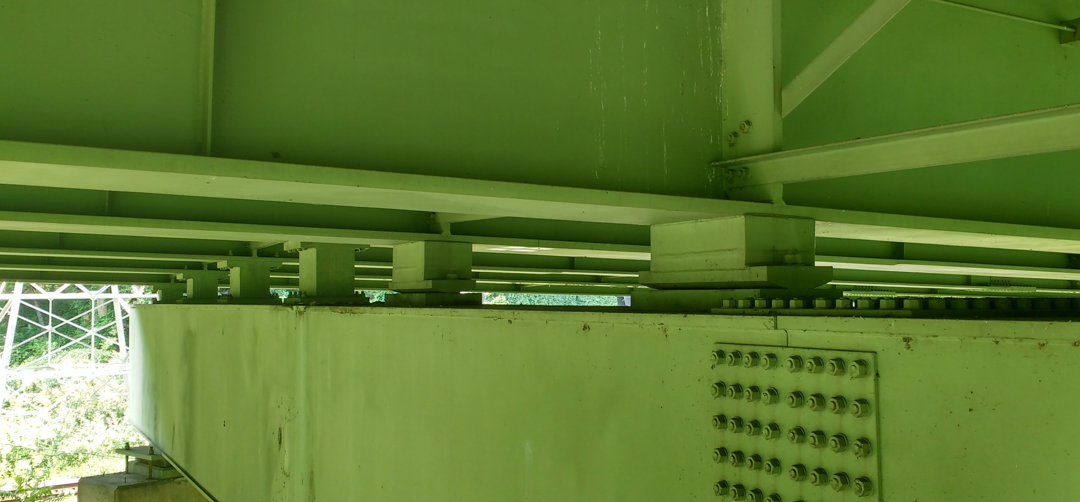

#### Condition

Visually, the deck appears to be in good condition, with no major cracking visible. Minor damage was observed in some regions of the center concrete barrier. The girders appeared in excellent condition. No major rusting was observed, and the girders appeared well maintained. The access hatches on many of the box girders had been left open. Any ill effects from this could not be immediately observed. The piers exhibited very little efflorescence and virtually no spalling. Repairs had been performed on several piers, where an embedded drainage pipe had rusted and caused a portion of concrete to spall off.

NBI Details

| NBI Structure Number | 000000000027280 |
| --- | --- |
| Year Reconstructed | 1986 |
| Owner | PennDOT |
| Skew | 0 degrees |
| Deck Width | 76’-6” |
| Maximum Span Length | 140’-0” |
| ADT | 57410 (2013) |
| Deck Condition | 6 (Satisfactory Condition) |
| Superstructure Condition | 7 (Good Condition) |
| Substructure Condition | 5 (Fair Condition) |
| Sufficiency Rating | 70 |

### Phase 1 Testing

The objective of the first phase of testing was to merely survey the structure so as to determine which portions of the structure were experiencing large vibrations, and begin to characterize those vibrations that may be “problematic”. Testing of the viaduct took place on July 6th and 7th of 2016.

#### Instrumentation Plan

The cross girders at piers 2, 3, 5 and 7 were instrumented with accelerometers to determine which spans experienced the highest levels of vibration. The accelerometers were positioned to capture the motion of the cross girder. On select cross-girders, accelerometers were positioned on one end of the cross-girder, on the bottom flange at mid-length, and on the web over the piers. These locations would provide information on the motion of the cross-girder in the vertical, longitudinal and transverse directions.

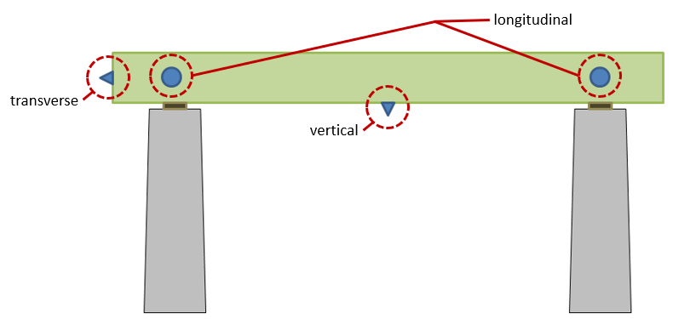

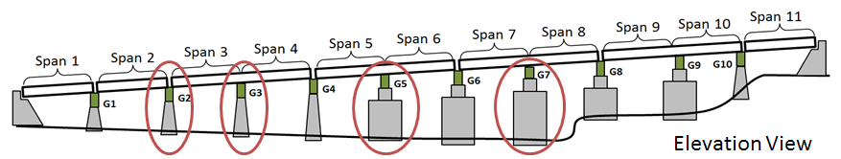

All accelerometers were attached to the steel structure with magnets. Data was sampled at 200 Hz for several hours.

#### Results and Interpretation

The resulting acceleration data was compared by examining and comparing time-histories for different cross-girders. All instrumented cross girders experienced similar levels of vertical and longitudinal acceleration, while the cross girder at pier 7 experienced much higher transverse acceleration. The transverse acceleration time history is shown below, while those for vertical and longitudinal acceleration are provided in the appendix.

|  |  |  |
| --- | --- | --- |
| Acceleration (g) |  | Pier 2 |
|  | Pier 3 |
|  | Pier 5 |
|  | Pier 7 |
|  | Time (sec) |  |

Figure : Transverse Acceleration Time Histories

To further compare acceleration the root-mean-square (RMS) was computed for each location over a period of 28 minutes. Because of the cyclic nature of structural acceleration that is nearly symmetrical about the zero line, an average of the data would return a value very close to zero. It is for this reason that the RMS was employed. A comparison of the RMS values at different locations is compared in the following charts.

Pier 2

Pier 3

Pier 5

Pier 7

It is suspected that the vertical motion of the bridge is that most felt by motorists and thus the response that should be most influential for deciding the region to perform further testing. However, as can be seen in the RMS comparisons above, the vertical acceleration is consistent between locations. While the longitudinal acceleration RMS does differ at different locations, the two sides (east and west) do not have consistent trends and therefore fail to identify a region of high excitation. Furthermore, while the RMS value for transverse acceleration clearly point to Pier 7 as experiencing the greatest excitation, it is uncertain that this direction of motion is indicative of the vibrations that have been reported and that are the subject of investigation. It can therefore be concluded that the bridge is experiencing similar levels of vibration across many or all of the spans.

Spans 7 and 8 were subsequently chosen for further testing. This decision was based on the available access to the superstructure as well as the evidence that span 7 may be experiencing slightly higher vibrations. It was also hypothesized that the taller piers supporting spans 7 and 8 would provide greater flexibility thus permitting greater deformation and more vibration.

### Phase 2 Testing

The objectives for the second phase of testing were (1) to characterize operational vibrations and strains at critical locations and locations of maximum response under various traffic conditions, and (2) to gather data for modal parameter identification (i.e. frequencies and mode shapes).

Instrumentation of spans 7 and 8 was installed on July 26th and 27th of 2016. Data was recorded on July 27th and 28th. Sensors were removed on July 29th.

#### Instrumentation Plan

A total of 30 accelerometers (PCB Model 393A03) and 12 strain gauges (Geokon 6" vibrating wire) were installed on the chosen region of the viaduct (span 7 & 8). The sensor locations are best described by the layouts provided in the following figures.

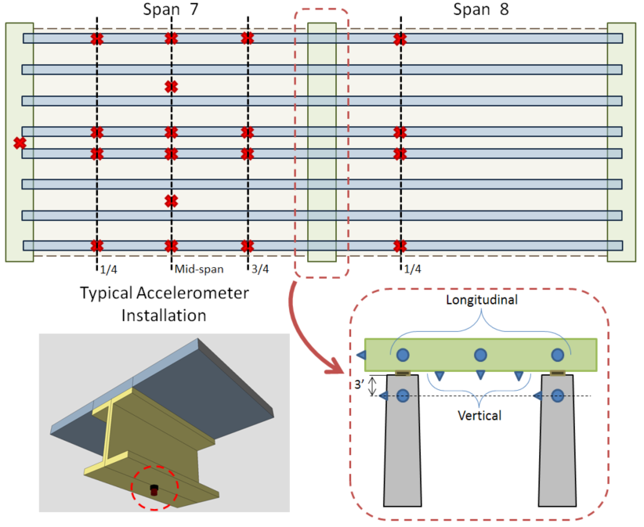

Accelerometers were positioned on the structure to capture several natural modes of vibration. They were therefore installed at locations that experience the greatest displacement for a given mode shape and at sufficient locations such that different modes may be distinguished from each other. By placing accelerometers as quarter-span, mid-span, and three-quarter span the first and second bending modes may be obtained. They are distributed transversely to capture torsional and butterfly modes. Span 8 received far fewer sensors due to a utility line that impeded access to much of the span. However, accelerometers were able to be installed along the first quarter-span line and provide the necessary data to determine the relative phase between spans for a given mode shape.

Strain gauges were installed to provide information on the stress inducing deformation of the structure and the influence of vibrations on that deformation. Gauges were therefore installed at locations expected to experience the greatest strain (i.e. mid-span & negative moment region) as seen in the instrumentation layout provided below.

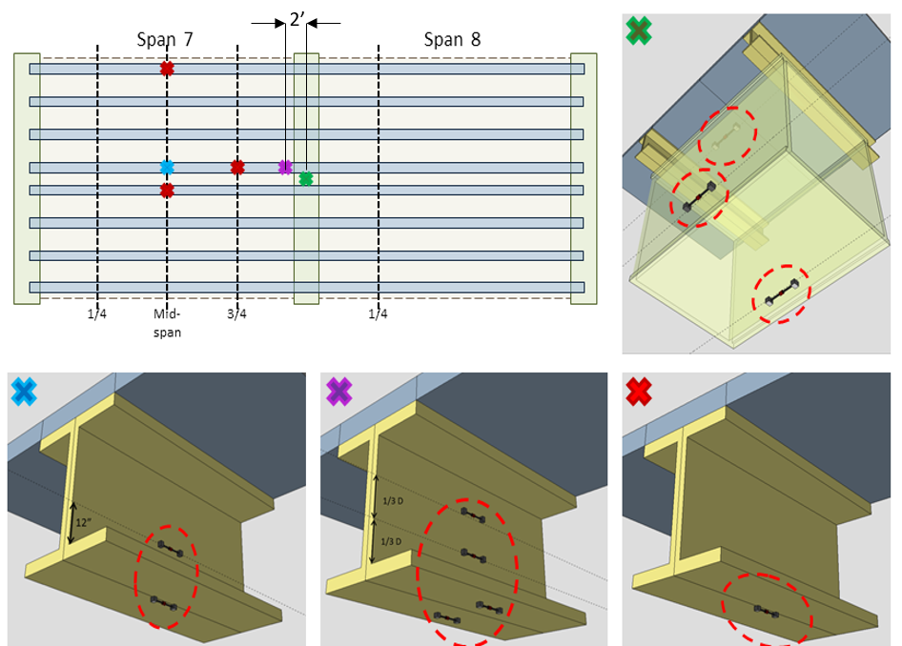

#### Test Activities

Accelerometers were attached to the steel superstructure with magnetic bases and attached to the concrete face of the piers with hot-glue (thermoplastic adhesive) after the surface had been cleaned with a steel-wire brush. Cables were clamped to the structure near the gauge to prevent the weight of the cable from damaging the gauge or affecting the readings.

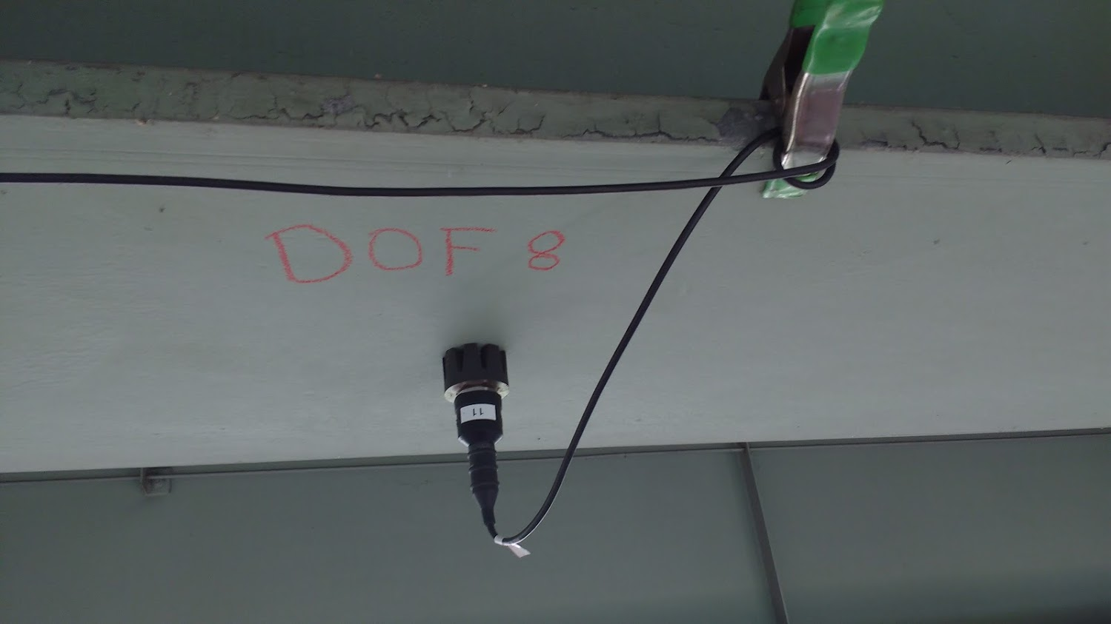

Strain gauges were installed by epoxying the mounting blocks to the steel surface. The surface was prepared by sanding off the paint until clean, bright steel was observed. The epoxy was allowed to cure for several hours before the gauges were locked into the mounting blocks. Tape was used to affix the gauges while the epoxy set. Cables were managed in the same manner as was done for the accelerometers.

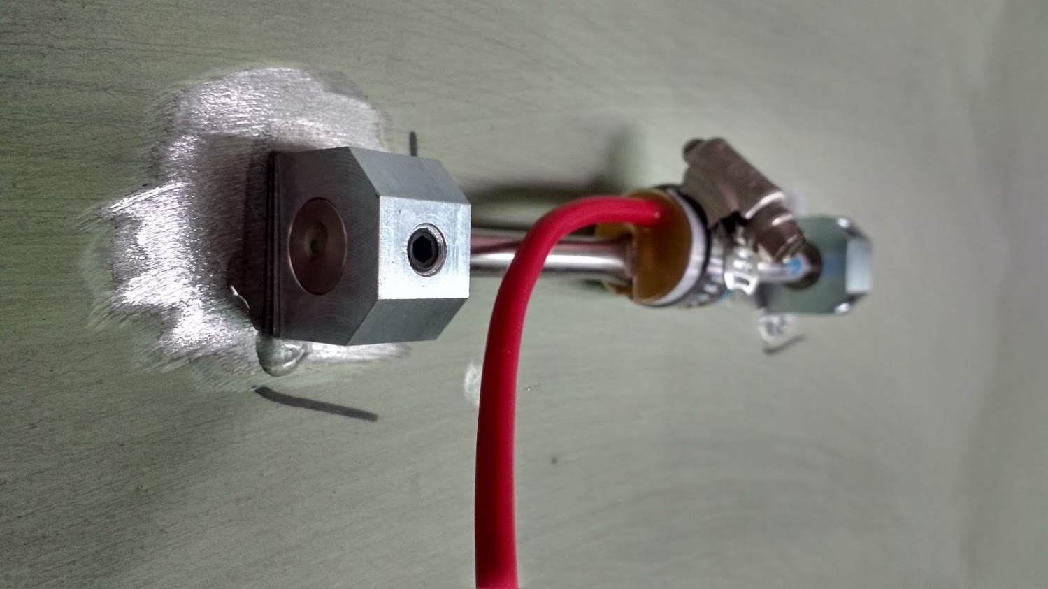

All accelerometers were sampled with a National Instruments CompactRIO (cRIO) controller outfitted with NI9234 modules for acquisition of the dynamic data. Data was gathered at 200 Hz for a total of 14 hours to capture the behavior of the bridge under differing operational conditions (e.g. rush-hour vs free-flowing traffic).

Strain gauges were sampled with a Campbell CR3000 datalogger along with (2) CDM-VW305 (Dynamic Vibrating-Wire Analyzer). Strain was sampled at 50 Hz for 12 hours and at 20 Hz over-night.

All gauges were removed from the structure at the conclusion of data collection. Paint was applied to areas that had been sanded.

#### Results & Interpretation

The acceleration data was filtered to remove high frequency content for time history plots as the high frequency content is associated with minimal structural deformation and therefore is of less interest. A low-pass elliptic filter was chosen for its steep cut-off slope. The filter was assigned an upper pass-band limit of 20 Hz, a pass-band ripple of 0.5 decibels, and 40 decibels of stop-band attenuation. The frequency response of the resulting filter can be seen in the following figure.



Figure : Frequency response of 6th order Elliptic filter

A sample time-history of acceleration with the above filter applied is shown below for girder 5 at midspan.



Over a period of 24 hours frequent traffic events were recorded for which the structure experienced acceleration greater than 0.2g. One such event is plotted below (Girder 5 at midspan of span 7). It is readily apparent that the structure is experiencing relatively low-frequency oscillations.



Spectral analysis of the records confirms that much of the motion occurs at low frequencies; between 2 and 4 Hz. The image below shows the power spectral density (PSD) for several locations, estimated using Welch's overlapped segment averaging (100 second segment lengths with 25% overlap and a total record length of 4.5 hours).



As can be seen from the spectral analysis plot, the majority of the vibration being experienced by this superstructure is occurring at frequencies between 2 and 4 Hz.

To estimate the displacement associated with these low-frequency vibrations the acceleration is first transformed into the frequency domain with an FFT, converted to displacement (divided by the radial frequency squared) and then transformed back to the time domain with an inverse FFT. To examine the displacement associated with a specific frequency range, only those frequency components within the specified range are included in the inverse FFT. In this manner the event previously presented (midspan of girder 5) was analyzed and is plotted below. Note that this displacement estimate considers only frequency content between 1.5 and 5 Hz and thus only represents a portion of the motion experienced by the bridge.

****Based on the displacements identified in the previous figure, the vibrations may be assessed against human comfort criterion. According to that set forth by Reiher and Meister (1931) and illustrated in the following chart, the bridge motion would be classified as “very disturbing. Furthermore, the deformation of the structure associated with this vibration is roughly 0.15 in. and therefore is likely to amplify to the live-load demands.

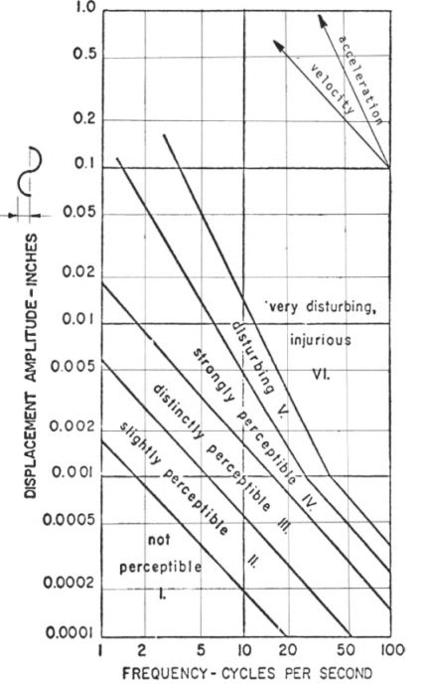

Modal parameter identification was also performed to extract the first 18 natural modes of vibration and their corresponding frequencies. They all occur within a frequency range of 2 to 10 Hz. The 18 mode shapes are plotted with their frequencies in the appendix. Mode shapes were extracted with the Complex Mode Indicator Function (CMIF) using software developed by J. DeVitis (**cite**). The mode shapes and frequencies will be used for model calibration.

A low pass filter of strain records for a typical event demonstrates the amplification of bridge response as a result of the vibrations. By considering the response content under 2 Hz as the static response, we may estimate the dynamic amplification factor. Data filtering was performed with a 6th-order low-pass elliptic filter with 0.5 decibels of peak-to-peak passband ripple and 50 decibels of stop-band attenuation. The filtered response was then compared to the raw-response in the plot below. As can be seen, this structure is routinely experiencing dynamic amplification of strain (and stress) in excess of 1.75. Furthermore, this amplification is occurring at design-level load events.

**Amplification by filtering**

#### FE Simulation

Several models were created with varying levels of detail including a 3D element-based model of spans 7 & 8. The model was calibrated/validated with the mode shapes and frequencies obtained experimentally. Multiple parameters were explored as a part of the calibration process. Ultimately, once moment releases were assigned to barrier beam elements at locations corresponding to joints, the model achieved close agreement with experimental results. A description of general modeling practices used throughout these studies is provided in the appendix.

##### Model Validation

##### Refined Load Rating

The calibrated models were used to assess the impact of observed dynamics on the bridge’s ability to carry load and its continued performance. Refined load ratings revealed that due to design conservatism there was sufficient reserve capacity to handle dynamic amplification even as high as 1.75. Furthermore, the calibrated FE model had parameter values (material properties, element connectivity, etc.) all within very reasonable bounds (i.e. there are no structural abnormalities contributing to the vibration issues). This iteration of testing therefore concludes that although the bridge is experiencing large vibrations, it does not appear to pose a risk to the bridge’s performance. However, the test results and simulations are unable to identify the cause of the vibrations.

### Phase 3 Testing

Previous testing demonstrated that vehicles were capable of exciting the mass of the structure. It became clear that we needed to better understand the coupled behavior of bridge and vehicle as it traversed the bridge. A test was therefore designed to capture the motion of a vehicle and bridge synchronously.

Accelerometers were distributed along the length of the bridge as well as placed on a test vehicle. This necessitated distributed data acquisition systems, one of which had to operate in a moving vehicle. GPS acquired time was used to provide synchronization.

A total of 36 accelerometers were installed on the bridge, distributed on spans 2, 3, 4, 7, and 8. Another 4 accelerometers were attached to the corners of a dump truck bed so the “roll”, “pitch” and “bounce” of the main mass of the vehicle could be captured.

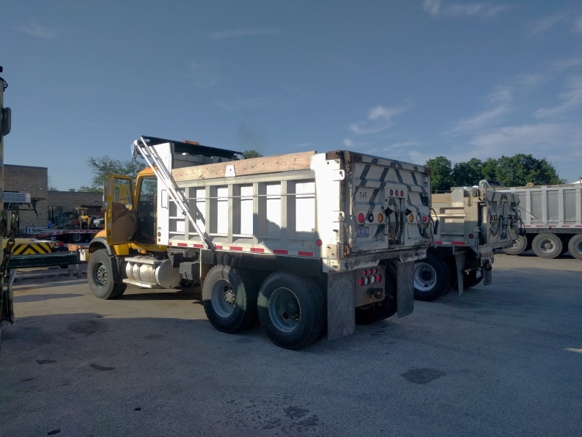

The dump truck was generously loaded to a total weight 47940 lbs. (21745 kg). Video cameras were placed at the beginning and end of the bridge, as well as at an elevated position near span 2. The test truck traversed the bridge 14 times. Vehicle speed and lane position were varied between runs but kept consistent throughout a single pass. Traffic conditions varied from free-flowing to heavily congested. A full description of the sensor layouts and testing activities can be found in the appendix.

#### Results & Interpretation

Acceleration records for the bridge show that it was excited by the test truck.

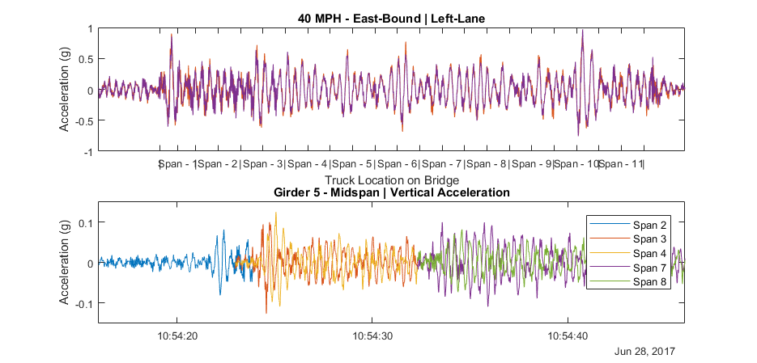

Examination of acceleration records for the test truck reveal that its motion is greatly increased when it is on the bridge deck versus when it is on normal roadway and acceleration increases with increased vehicle speed. The plot below uses the short-time Fourier transform (STFT) to show the frequency content of the truck acceleration as it changes over time. It is evident from the plot that the truck begins to resonate shortly after entering the bridge at a frequency of 2-3Hz.

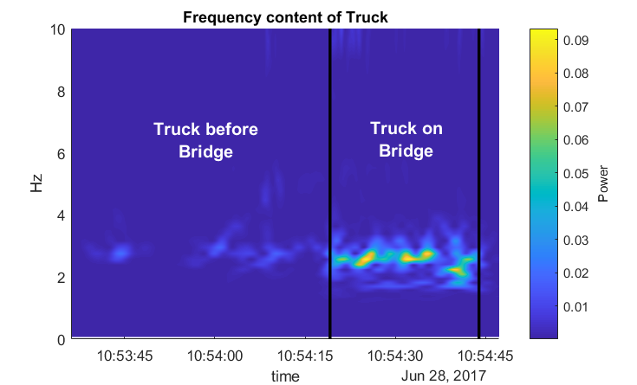

Spectral analysis of truck acceleration data on normal roadway shows the truck has a natural frequency of approximately 2.7Hz. High damping in the vehicle serves to broaden the natural frequency peak, preventing precise modal parameter identification but also providing a range of forcing frequency content that the truck would be vulnerable to.



These test results further confirm that the bridge vibrations are a result of vehicle-bridge interaction in which both the vehicle and bridge are experiencing significant excitation. Simulation is required for further understanding of the mechanisms and influential parameters associated with this behavior.

#### FE Simulation

An FE software package was chosen (LUSAS) that was capable of simulating vehicle-bridge interaction. This required the ability to model the geometry and dynamics of the bridge as well as the dynamics of a vehicle traveling over the bridge model. A 3D model of spans 7 and 8 was first created based on the model that had already been calibrated and made to match natural frequencies. This model was expanded to include all 11 spans of the bridge. The test truck was modeled as sprung mass. Its mass was determined from the recorded weight of the dump truck and the suspension parameters (stiffness and damping) were assigned such that the sprung-mass natural frequency matched the measured frequency of the test vehicle “bounce”. Additional description of the modeling can be found in the appendix.

Initial simulations did not include any roadway profile and therefore inherently assumed a perfectly smooth profile. It very soon became clear that neglecting the roadway profile in the simulations greatly under-predicts the bridge responses. The in-situ roadway profile was subsequently measured for implementation in further simulations. Details regarding the measurement of roadway profile are included in the appendix.

Simulations of the testing scenarios were performed with the roadway profile included. A few parameters were unknown or known with poor accuracy and therefore were adjusted in the model until its predictions agreed with the experimental results. These parameters included vehicle speed and vehicle damping. The following plot compares experimental acceleration data to FE simulation.

These simulation results demonstrate the model’s capability of simulating vehicle-bridge interaction and the role of roadway profile on that interaction.

### Test Conclusions

As a result of the tests performed on the case structure the following may be concluded.

* The bridge is experiencing motion that exceeds human comfort criterion.
* The high vibration levels are occurring on all spans (that were instrumented).
* The bridge exhibits dynamic amplification as high as 1.75 even under heavy vehicles (compared to AASHTO recommended 1.33).
* The high dynamic amplification is not a result of any structural deficiency or anomaly.
* The high dynamic amplification does not seem to pose a risk to the structure’s performance (at strength or service limit states).
* The vehicle is excited by the bridge deck profile, which in-turn excited the bridge
* A validated 3D FE model is capable of simulating bridge-vehicle interaction if roadway profile is included and accurately positioned on the model.

The framework of structural identification was followed throughout the many tests performed on this test structure. In this way testing provided ground truth of behavior which served to validate simulation tools, which were, in-turn, leveraged to investigate structural behavior that would be impossible or impractical to capture in the field. The remainder of this paper implements these validated tools to gain further understanding of vehicle-bridge interaction and dynamic amplification.

## Simulating VBI

In several of the simulation studies described in this section a simplified model was employed. This model is composed of 2 degrees-of-freedom and reduces the bridge to a single beam. This model type was used when appropriate due to the minimal computing power required, permitting a large number of simulations to be automated and performed in a relatively short amount of time. This model (state-space) is described in detail in the second part of this document and in the appendix.

### Bridge and vehicle decoupled

In the interest of further understanding the degree to which the vehicle and bridge interact, the vehicle is analyzed separately from the bridge. The vehicle’s motion is simulated as it traverses the bridge deck profile. The contact force is calculated based on the vehicles motion. That contact force can then be applied to a bridge model to simulate bridge responses to the moving vehicle. This method neglects bridge motion and therefore represents a completely rigid bridge. Therefore, this method’s accuracy will suffer with increased bridge flexibility and vehicle mass.

The following plot compares coupled and uncouple models for vehicle contact force and bridge displacement. Due to FE software limitations the simplified 2-degree of freedom model was used. 

**Redo above plot with case known to have high amplification.**

Despite the simplicity of the model used to obtain the above results, it is still effective at modelling the exchange of energy of two systems. As can be seen…

### Mechanisms and Influential Attributes

Many studies on vehicle-bridge interaction will examine the role of parameters separately, and it was the original intention to organize this study in a similar manner. However, as it will soon be made clear, the parameters that effect VBI are interdependent. The following section therefore seeks to demonstrate and characterize the interdependency by first examining roadway profile which the case study showed to be critical to VBI and dynamic amplification.

A given profile is composed of elevation changes over the length of the roadway. This surface may be approximated by a summation of harmonic functions, and thus spectral analysis may be performed in much the same way as was done for acceleration data. The profile can therefore be described by its spatial frequency (cycles per unit distance) content. When a vehicle travels over a harmonic profile, the elevation change experience at the vehicle’s location is harmonic according to the velocity of the vehicle. A profile with a given spatial frequency will induce a force that acts on the vehicle with a frequency equal to the product of the spatial frequency and vehicle velocity. Therefore, the effect of the profile spatial frequency content is dependent on the velocity of the vehicle.

**Several simulations with a 3D FE model were performed for a sinusoidal profile with 30 foot wavelength and ½ in. amplitude.** The plot below shows the peak vehicle and bridge response at different vehicle speeds and the resulting forcing frequencies. It is no surprise that the peak responses occur at speeds that induce a forcing frequency that matches their respective natural frequency.

Additional simulation was performed with the simplified state-space model. Vehicle stiffness was varied to produce vehicle models with natural frequencies ranging from 1 to 5 Hz. Bridge stiffness was also varied to produce bridge models with natural frequencies of the same range. Simulations were performed at several vehicle speeds to produce forcing frequencies also between 1 and 5 Hz. The following plot summarizes the results of this parametric study.

The above plot demonstrates the role of the profile as well as other parameters in vehicle-bridge interaction. The profile best excites the vehicle when its forcing frequency matches that of the vehicle, and the bridge is most excited when the profile forcing frequency matches its own natural frequency and that of the vehicle.

However even a harmonic profile cannot be entirely described by its frequency content. The distribution of phase angles for the different harmonic components have a large effect on the final form of the profile and how the vehicle-bridge system responds to that profile. The following plot compares bridge response for two profiles with identical frequency content but different phase angle distribution. Similarly, the position of the profile can make a large difference in vehicle and bridge response. Simulations were performed with a single profile whose position was varied by 10 feet.

Furthermore, most real profiles are not harmonic but rather have many transient features. Profiles that contain features with large wavelengths that result in forcing frequencies similar to vehicles or the bridge should be avoided (e.g 5-50ft.). However, the frequency content of the profile alone has no reliable correlation with dynamic amplification and spatial information must be included in any dynamic amplification analysis.

Vehicle and bridge parameters therefore effect dynamic amplification based on their influence on the dynamics of the system and how those system dynamics relate to the profile characteristics. While parameter effect cannot be quantified they can still be generalized as follows:

* Higher bridge mass, stiffness and damping generally serve to reduce dynamic amplification.
* Higher vehicle mass increases dynamic amplification while vehicle damping helps to reduce amplification.
* Higher vehicle speed leads to increased dynamic amplification.
* Longer bridge length results in a longer period of time for which the vehicle is present on the bridge and may therefore result in greater dynamic amplification.

Anything further than these generalizations requires simulation of vehicle-bridge interaction with the specific profile or direct measurement by field experiment.

# Part 2: Estimating Dynamic Amplification

There are two widely used factors for expressing dynamic amplification. They are referred to as impact factor (IM) and dynamic amplification factor (DAF) and are defined by the following equations:

|  |  |
| --- | --- |
| $$IM=\frac{Dynamic Response-Static Response}{Static Response}$$ | (1) |
| $$DAF=\frac{Dynamic Response}{Static Response}$$ | (2) |

Therefore, the IM is just $DAF-1$. The total live load response can be computed by the following:

|  |  |
| --- | --- |
| $LL=\left(1+IM\right)*R_{sta}$*or $LL=DAF*R_{sta}$* | (3) |

Where Rsta is the static load effect which is amplified by (1 + IM) or the DAF.

In this paper the dynamic amplification factor will be expressed in terms of **Equation 1**. The responses used in computing the factor may be any structural response, experimentally recorded or obtained though analysis. Experimentally determined amplification factors often use either strain or displacement. Amplification factors determined with displacement will be greater than those determined from strain (or stress or moment) due to the distribution of load from the mass loading that is ignored in static analysis. A computational proof of this is provided in the appendix. Therefore, experimentally determined displacement amplification factors will be a more conservative measure of dynamic amplification, but strain amplification factors remain adequate as strain responses more directly measure the stress experienced by the bridge.

## Visualizing the Problem

The excitation of the vehicle-bridge system is due to the contact force between the vehicle tire and roadway surface. This contact force is dependent on the difference in vertical position of the bridge surface and the vehicle body. The bridge surface elevation is the combination of bridge motion at the vehicle position and elevation added by the profile. It therefore follows that any model of vehicle-bridge interaction must include the following:

* The mass of bridge excited by the vehicle-induced forces
* The stiffness of the bridge
* The mass of the vehicle
* The suspension characteristics of the vehicle
* The vehicle velocity
* The roadway profile accurately positioned on bridge

This last element, an accurately positioned profile, is critical. The effect of a profile feature (bump) is partially dependent on the location of the feature, therefore an accurate model must also include longitudinal (along path of travel) bridge geometry (e.g. span length).

There are many different methods of representing all of these elements in a model, but the success of a model is ultimately judged by its ability to reliably estimate the response of interest. For this study that response of interest is the amplification of peak responses during live load events (vehicle-crossing). The following sections will present several model types of varying complexity, document their construction and demonstrate their ability to predict dynamic amplification.

## In-Situ Measurement

There is no substitute for directly measuring a phenomenon. This section provides guidance on methods of directly measuring the dynamic amplification being experienced by a bridge that is in-service.

### Operational Monitoring

Often operational monitoring, whereby bridge response is recorded during normal operation, is the cheapest method and least disturbing to traffic and provides responses to typical loading conditions. Members that are expected to experience the largest responses as well as those suspected to have the least reserve capacity should be instrumented. Sensors should be carefully selected based on required response, range, accuracy, etc. This study is principally interested in material level responses (i.e. stress). Strain is directly related stress and thus strain gauges are preferred for measuring dynamic amplification. Displacement gauges can be used but tend to overestimate amplification as discussed previously (Part 1). Acceleration gauges may be used to estimate displacement if they remain accurate at frequencies near zero. This requirement is true of any gauge chosen, but is more likely to be an issue with capacitive accelerometers.

The process of determining dynamic amplification from operational responses has been already detailed by other researchers. Regardless of the exact method used, the data is filtered to remove high frequency content leaving behind the content associated with quasi-static loading. The dynamic amplification is then estimated by computing the ratio of the maximum of the original data to the maximum of the filtered data. A demonstration of this process can be found in the case study presented in the first part.

The filter parameters should be selected such that the pass-band upper limit is less than the first natural frequency but greater than the frequency of loading. In reality, some loading events occur faster than the first natural frequency of the structure. In these cases the filtered response under-estimates static response, subsequently resulting in an over-estimation of amplification. This problem is mitigated by the large mass of the bridge which resists rapid motion, but is always an inherent source of error when estimating static response from operational responses. Furthermore, it is unlikely that the “worst-case” scenario occurred during the record interval and thus the estimated amplification can be non-conservative, but can be appropriate for operational limit states and is a valuable approximation for assessing in-service performance.

### Load Testing

The static response of the bridge can be measured directly when the load is applied statically as in a load test. Responses should be recorded for the test-vehicle (loaded truck) motionless as well as travelling over the bridge at speeds corresponding to minimum, typical, and maximum traffic speeds. Dynamic amplification computed from the resulting static and dynamic responses will be accurate for that specific test-vehicle, but is not guaranteed to remain conservative for all loading events. A bridge’s performance in design or evaluation is measured by its ability to carry limit-state loads. Test-vehicles should therefore be loaded to a weight similar to the legal load limit. When possible, test-vehicles should also be chosen with a body-bounce natural frequency similar to that of the first-bending mode of vibration of the bridge as this has been shown to result in the greatest dynamic amplification.

The test-vehicle should be placed at locations that produce maximum response or made to “crawl” at speeds low enough to maintain “quasi-static” conditions for the static portion of the load test. The dynamic load test should occur at various speeds and along all paths of travel. The test vehicle must begin a significant distance from the start of the bridge to account for vehicle motion as a result of traversing the approach roadway. The test-vehicle should maintain the set speed from a distance of at least 65 feet (20 meters) away from the beginning of the bridge until it exits the bridge.

### Profile Measurement

In some cases it becomes necessary to simulate the bridge response to moving vehicles. Any simulations of vehicle-bridge interaction must include bridge deck profile. The profile should contain paired position and elevation information along the entire length of the bridge and approach roadway for every reasonable path of travel. Elevation data may be recorded along a single line or along multiple wheel lines. The spatial resolution should be set small enough to capture all features of interest. Bridge motion is most effected by profile features with a length of several feet and more. Commercial profilographs have sampling intervals on the order of one inch and thus can be expected to produce perfectly adequate profile measurements.

## Finite Element Analysis

There are often scenarios in which it is impractical or even impossible to implement certain loading events or measure certain responses. In such circumstances it becomes necessary to perform simulation of the loading event to predict expected responses. The selection and construction of a suitable model for these simulations is critical to accurate predictions.

A 3D element-level FE model is capable of representing all mechanisms and features that are a part of vehicle-bridge interaction and influence dynamic amplification. By creating a model that is geometrically consistent with the real structure the mass and stiffness can be accurately modeled and spatially distributed. The model should be error-screened and calibrated with experimental data from the real structure and should have at least the first natural frequency matching that of the real structure.

It is not the aim of this paper to provide guidance on constructing and validating FE models. The exact methods of model construction and analysis are dependent on the FE software package employed. The selected FE software should be capable of simulating moving sprung masses over a specified profile and bridge model. The model should be constructed using best practices and should be validated with experimental data whenever possible. Validation with dynamic data (e.g. frequencies and mode shapes) is preferable and ensures the model dynamics match those of the structure.

The vehicle can be modeled after a real vehicle by assigning equivalent mass (weight) and by setting suspension characteristics that result in matching body-bounce natural frequencies. If there is no reference vehicle, a worst-case vehicle model may be created that has a mass equal to the legal limit, low damping (e.g. 10%), and a suspension stiffness that results in a body-bounce frequency 10% greater than the bridge’s first-bending natural frequency.

Static responses can be simulated with vehicle at a crawl-speed (i.e. <1mph) or with a static linear analysis of the vehicle placed in locations that produce maximum response. Simulated responses should be recorded at locations of maximum response or particular vulnerability. Dynamic amplification can be computed for a given location as the ratio of maximum dynamic response to maximum static response.

The case study provided in the first part of this document demonstrates the process of estimating dynamic amplification with 3D FE analysis. The plot below compares bridge responses that were recorded during operational monitoring to those predicted by 3D FE simulation.

## 2D Condensation & State-Space

Although 3D FE analysis is capable of accurately simulating vehicle-bridge interaction and estimating dynamic amplification, it is often impractical for current engineering practice due to the required time and expertise. It is therefore advantageous to develop models that require minimal time and expertise while still providing accurate estimates of dynamic amplification.

### Description

The following pages present a model type that includes all of the mechanisms involved with vehicle bridge motion as listed in the beginning of this part. The model reduces the bridge to a generalized single degree-of-freedom (SDF) system for which its deformation at any point along the bridge’s length is defined by a shape function. The vehicle is also represented as a single sprung mass and is coupled to the bridge degree-of-freedom. The equations of motion for this generalized SDF system are relatively simple and are used to develop state-space equations that define the position of both bridge and vehicle. A full description of this model and supporting derivations are provided in the appendix. The following image illustrates the model components.

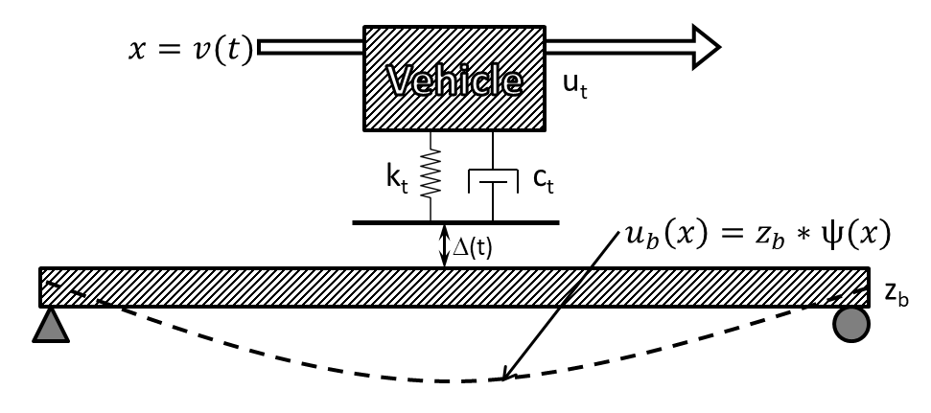

Models were developed for singles-span bridges and for 2-span continuous bridges with equal span lengths. Although these models include every mechanism that plays a role in dynamic amplification they have several inherent limitations:

1. A sine wave ($\left(x\right)= \sin\left(\frac{πx}{L}\right)$) was chosen for the shape functions that generalize the distributed systems by defining the shape of the beam deformation. While this shape function accurately describes the deformation associated with the first-bending mode of vibration, it is incorrect for point loading (or any other loading).
2. The single shape function cannot account for the excitation of the bridge’s higher modes of vibration.
3. By modeling the bridge as a single beam, the lateral distribution of mass and stiffness is neglected.

While these and other limitations leave the models much less capable than a full 3D FE model, they may still prove useful for estimating dynamic amplification and require a fraction of the time investment and computing power.

### Implementation

The first step in determining the appropriate parameters for defining the state-space model is to define a beam that can approximate bridge response due to a vehicle traveling along specified path of travel. The distributed stiffness (EI) can be approximated by first determining the stiffness of the bridge to a point load at midspan along the path of travel. This stiffness value may be determined experimentally or with a refined FE model. The appropriate EI value is subsequently calculated that produces a beam with an equivalent stiffness value. Stiffness is assumed to be uniformly distribute (i.e. EI is constant along the length of the beam. The following equations describe that calculation for single-span and two-span models.

$$EI=$$

Once the distributed stiffness of the beam is determined, the distributed mass of the beam may be calculated such that the beam has a first-bending natural frequency equal to that of the bridge. Mass was assumed to be uniformly distributed along the length of the beam for the models presented herein.

The vehicle is also reduced to a single degree-of-freedom based on known mass and natural frequency as described for FE simulations. Conservative vehicles may be implemented that have mass equal to legal limits and suspension stiffness that results in a body-bounce natural frequency approximately 10% greater than the bridge natural frequency. The profile should be measured and provided in the form of sequential distance and elevation measurements. The distance values should be monotonically increasing.

Full instruction on how to implement the state-space model is provided in the appendix and accompanying computer code is available upon request (if not already publicly available). While the state-space model directly computes bridge displacement, the amplification (and other response quantities) is easily computed and is the quantity reported in many of the supporting figures. It became quickly evident that the error of these simplified models was mitigated by computing amplification rather than deflection. This is not surprising as it serves to reduce the effect of bridge stiffness, a parameter which is represented in vastly different ways (3D element-level vs SDF). It should also be noted that structural responses (e.g. displacement) should not be interpreted directly from these simplified models. Rather these models are intended to predict the amplification of responses.

### Validation and Performance Assessment

The models previously described were implemented in MATLAB. The models were error screened by first comparing output to FE models of corresponding beams. Some error was expected (and observed) because the state-space models are still an approximate representation of beam behavior. That error was more pronounced for models of two-span continuous beams. Additional details of the benchmarking can be found in the appendix.

It is always preferable to measure a model against ground truth values, which in this case would be the dynamic amplification as recorded on an actual structure. However, there are not enough structures that have been instrumented for the determination of dynamic amplification and have also had their profile measured. There are simply too few samples from real structures to adequately assess the performance of the state-space models. As a result, the performance of the state-space models was evaluated by comparing the dynamic amplification predicted by the model to that predicted by a 3D FE model. A total of six 3D FE models were constructed based on actual structures that had been previously subjected to dynamic testing. The roadway width of some of the models was great enough to accommodate multiple lanes and therefore multiple paths of travel were defined. A more detailed description of the FE models is provided in the appendix.

A total of 15 profiles were evaluated. Three of the profiles were obtained from the profiles recorded from the case study bridge. Another twelve were artificial and generated using the methods defined by the ISO 8608 standards. This standard defines a roughness metric, but also describes the process whereby the profile is defined by frequency content and is generated through the summation of sine functions.

Several vehicles were defined with parameters that resulted in body-bounce natural frequencies equal to the first natural frequencies reported by the FE models. The mass of all vehicles was set to 200 slinches (77.2 kips). Three vehicle models were assigned damping ratios of 10%; one was assigned 20%. Further description of modeling decisions and parameters are provided in the appendix.

The four parameter categories (i.e. bridge, path of travel, vehicle, and profile) were sampled to obtain a total of 239 different scenarios. Each scenario was simulated with a detailed 3D FE model and with a state-space model. The predicted amplification is compared in the plots below. It can be observed from these plots that the state-space models are more conservative for scenarios that result in high levels of amplification, but more accurate at lower amplification levels. It is not expected that dynamic amplification will reach such high values on real structures. These values were obtained in simulations with unrealistically rough artificial profiles, but still serve to demonstrate the performance of the state-space models.

## IRI & Other Vehicle-Only Models

There are several methods already widely used to assess the roughness of roadway profiles. The International Roughness Index (IRI) is the most complex and simulates a specified vehicle (golden quarter-car) traveling over the profile. Other metrics ignore the vehicle and deal only with the profile data. The ISO 8608 parameters, for example, describe the spatial frequency content of the profile. However, all of these roughness metrics fail to consider the bridge or the position of the profile. Studies were performed to examine if these metrics had any ability to predict dynamic amplification.

ISO 8608 parameters describe the spatial frequency content of the profile. Studies presented in the first part of this document show that the spatial frequency of the profile content does influence dynamic amplification. However, these parameters ignore any transient features and ignore the phase angle distribution and therefore are inadequate for predicting dynamic amplification. This is evidenced by the plot below which compares the bridge response for two profiles with identical ISO parameters but different distribution of phase angles. The inadequacy is further demonstrated by the supplied correlation plot.

PLOTs

The IRI includes the vehicle in its model and may be expected to demonstrate better ability to predict dynamic amplification. However, a correlation plot shows that the IRI cannot reliably predict dynamic amplification. The plot also reveals that while profiles with high IRI may not always result in high dynamic amplification, bridges with high dynamic amplification have high profile IRI values. This provides further encouragement to encourage and mandate a smooth deck surface.

PLOT

Another simple model was assessed that included representation of the vehicle, but ignored bridge behavior. Position of the profile on the bridge was included by applying a sine window to the vehicle response over the time period for which the vehicle is on the bridge. The maximum of the windowed contact force is reported as a factor of the vehicle self-weight. This contact-force amplification metric is compared to FE predictions in the plot below. The metric consistently correlated with dynamic amplification for some bridges, but was not widely applicable and therefore is not recommended for any amplification predictions.

PLOT

## Summary

* The vehicle and bridge comprise a coupled dynamic system that is energized by the vehicle traversing a profile.
* Dynamic amplification estimated by filtering operational monitoring data may over-estimate amplification.
* Determining dynamic amplification of in-service bridges may be performed with operational monitoring or a load test. In either case, strain gauges are recommended over displacement gauges or accelerometers.
* A 3D FE model is capable of simulating vehicle-bridge interaction and is recommended for predicting dynamic amplification for structures with complex geometry or that are otherwise ill-suited to the state-space models.
* A simple model that reduces both the bridge and vehicle to SDF systems has been shown to reliably predict dynamic amplification, and is recommended if FE simulation is not practical.
* Any metric that is to be used for predicting dynamic amplification must include a representation of the bridge. Therefore dynamic amplification should not be predicted by current roughness metrics (e.g. IRI and ISO 8608) that only consider the profile and vehicle.

# Part 3: Applications in Vehicle-Bridge Interaction

Several tools have been shown capable of simulating vehicle-bridge interaction and are leveraged in the following pages to further our understanding of dynamic amplification.

## Remediation and Smoothness Criteria

If a bridge is suspected to exhibit large dynamic amplification as a result of a rough roadway, the bridge owner may wish to grind the roadway smooth. Furthermore, to reduce dynamic amplification in new construction, deck profile specifications should provide smoothness targets. Currently, smoothness criteria are prescribed differently for different locations. Most US states

The ability of these criteria to limit dynamic amplification is assessed by examining a problematic profile, and then evaluating the reduction in amplification if the profile is smoothed according to specified criteria.

The IRI which is widely used as a smoothness criterion by providing upper limits, has already been shown to influence dynamic amplification. The IRI is a measure of vehicle response and can therefore only be implemented as a performance metric. As such it provides no methods for specifying or monitoring of smoothness during construction or grinding and will not be presented in this section. However, if a deck profile is shown to have a high IRI, intervention should be considered.

Rolling straightedge requirements are widely used for specifying localized roughness criteria and are expressed in terms of deviation over a certain length. Parameters commonly range from 1/8 to ¼ inch deviation over a 10 to 16 foot distance. The plots below illustrate the ability of straightedge requirements to limit dynamic amplification.

PLOTS

The straightedge requirements effectively target features within a range of lengths. At normal traffic speeds profile features with lengths of **5-20 feet** result in forcing frequencies within the range of natural frequencies commonly exhibited by bridges. Therefore, the straightedge length should be specified long enough to avoid/remove long features. The effects of a variety of straightedge lengths are compared below.

PLOT

## Vehicle Configurations

The many simulations that have thus far been reported, have considered a single vehicle traversing a bridge. In reality, bridges experience a large variety of different live-load configurations and many times are subjected to multiple vehicles at the same time.

### Traffic

The scenario of multiple-vehicle loading is accounted for in most design methodologies through the use of multi-presence factors. These factors serve to reduce the load presented by vehicles in adjacent lanes based on the assumption that vehicles with legal-limit weights are unlikely to occupy adjacent lanes at the same time. While this assumption may be valid for bridge response to static loads, other vehicles, including light vehicles (e.g. small passenger vehicles) may contribute to the dynamic response. The effect of other vehicles (traffic) on a bridge’s dynamic response and the dynamic amplification of a major load event are investigated.

### Truck Trains

### Future Work